*WhenToWork – Scheduler Training Guide*

All Hourly staff members will be scheduled for regular work shifts using **WhenToWork**, an online scheduling and communication tool. As long as there is a connection to the internet, employees can access WhenToWork anytime, anywhere using a web browser (on a computer or Apple Device), or a downloadable app (on an android device).

A Manager account has been created for you. You will receive login information via email, and will need to create a login and password.

Employees will be responsible for updating and maintaining contact information. WhenToWork will send notifications using email and text messages depending on the preferences set by the employee.

Supervisors will create schedules based on the availability of their staff members. After an account has been created, employees will check WhenToWork regularly and use it to:

* View your work schedule
* Find a substitute
* Pick up additional shifts for others trying to find a substitute
* Communicate with your supervisor and/or co-workers on schedule-related issues
* Request days off
* Check the message board for important information posted by your supervisor

Staff schedule availability, including any subsequent changes in the ability to work assigned shifts, should be submitted in the manner described by division supervisors. For example, there may be specific guidelines for the amount of advance notice needed when requesting time off. These guidelines may differ between divisions and may change due to scheduling needs around holiday periods. Any questions about these guidelines should be directed to your supervisor.

WhenToWork should generally **not** be used for shift cancellations within 24 hours, especially for those who are assigned to work at a public service point. Instead, please speak with your supervisor or someone in the division so that other arrangements can be made to cover the immediate scheduling need.

Contents

Accessing WhenToWork 1

Logging into WhenToWork for the First Time 2

Personal Home Page 3

Getting Help with WhenToWork 4

Forgotten or Invalid Sign-in ID/Password 5

WhenToWork Online Scheduling - Before you begin 6

3 Step Overview of Setting up Automatic Scheduling 6

Add Your Employees 7

To ADD Employees 7

Add your Positions (Jobs) 8

To Add a New Position 8

Creating a Schedule 9

Enter a Previous Schedule Week - Add Shifts 9

To add your First Shifts use the "By Employee" Schedule View. 9

Optional information that can be entered for any shift 10

Import a Previous Week (or Saved Template) 11

To Create (or add shifts to) a Schedule using Import: 11

Make Quick Schedule Changes using the "By Employee" Schedule View 12

To Edit an existing shift using the By Employee view 12

Add Notes to the Weekly Schedule 14

Publish Your Schedule 15

Make Schedule Changes (after Publishing) 16

Create a WEEKLY Schedule Template 18

How to create a WEEKLY Schedule "Template" 18

Import Shifts into a Week or Day 19

To Import All Shifts 19

Change a Saved Template (Edit a Template) 20

To make changes to or edit a Template: 20

Delete a Schedule Template 21

Change Layout - Font size, Name Order, Sorting, etc. 22

Overview of the 12 Schedule Views 23

Standard Schedule Views 23

Special Schedule Views 23

To MOVE a shift to another day/employee 24

On the By Employee schedule view 24

To COPY a shift to another day/employee 25

To SWAP two shifts 25

## Accessing WhenToWork

From a computer or apple device, open a web browser and go to: [www.whentowork.com](http://www.whentowork.com)

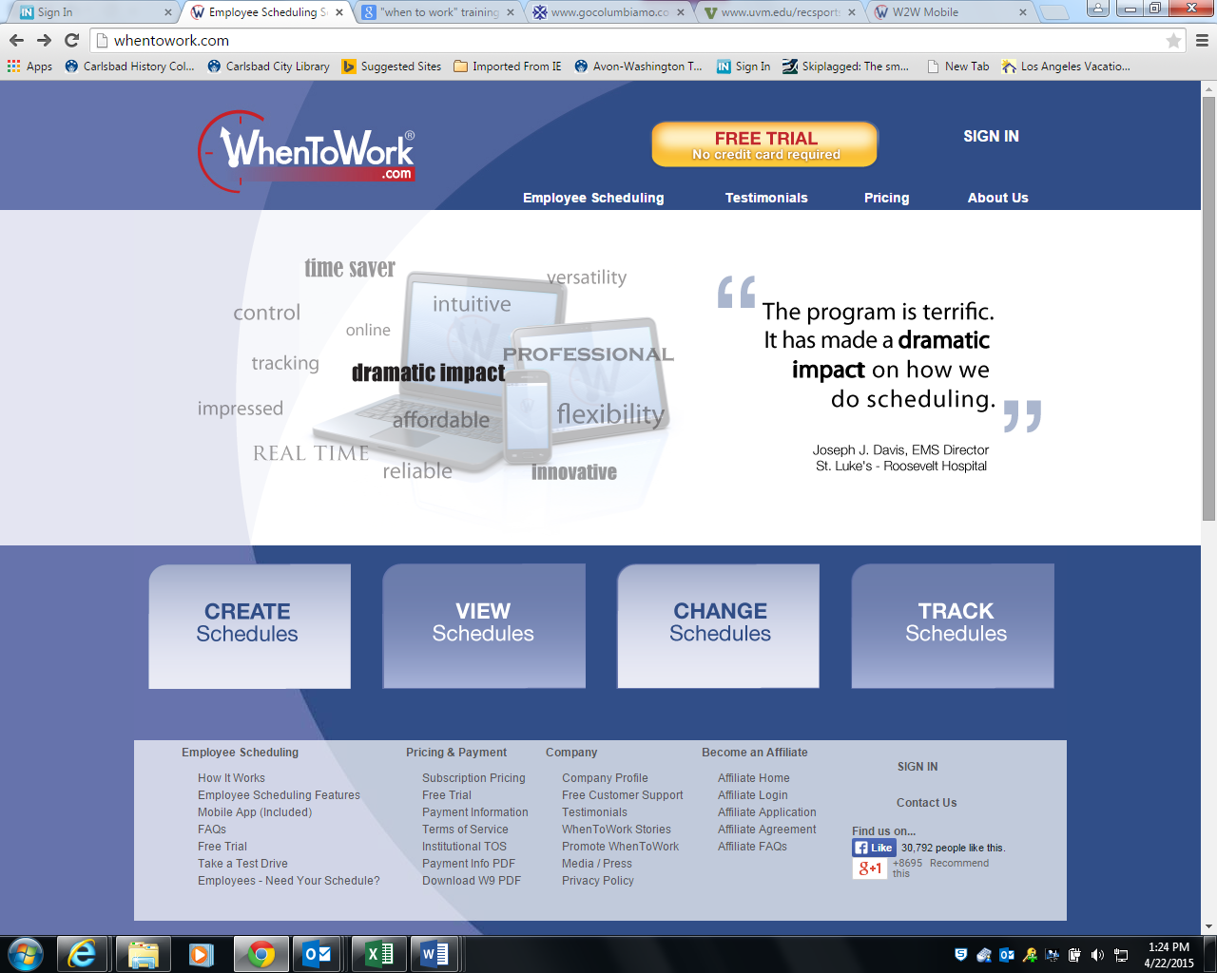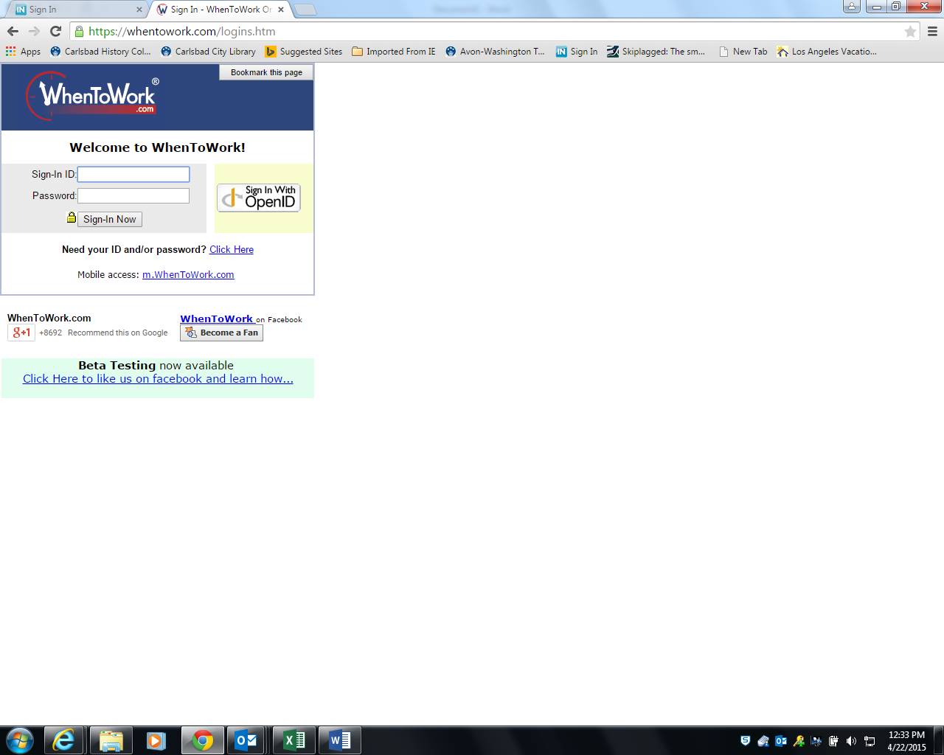

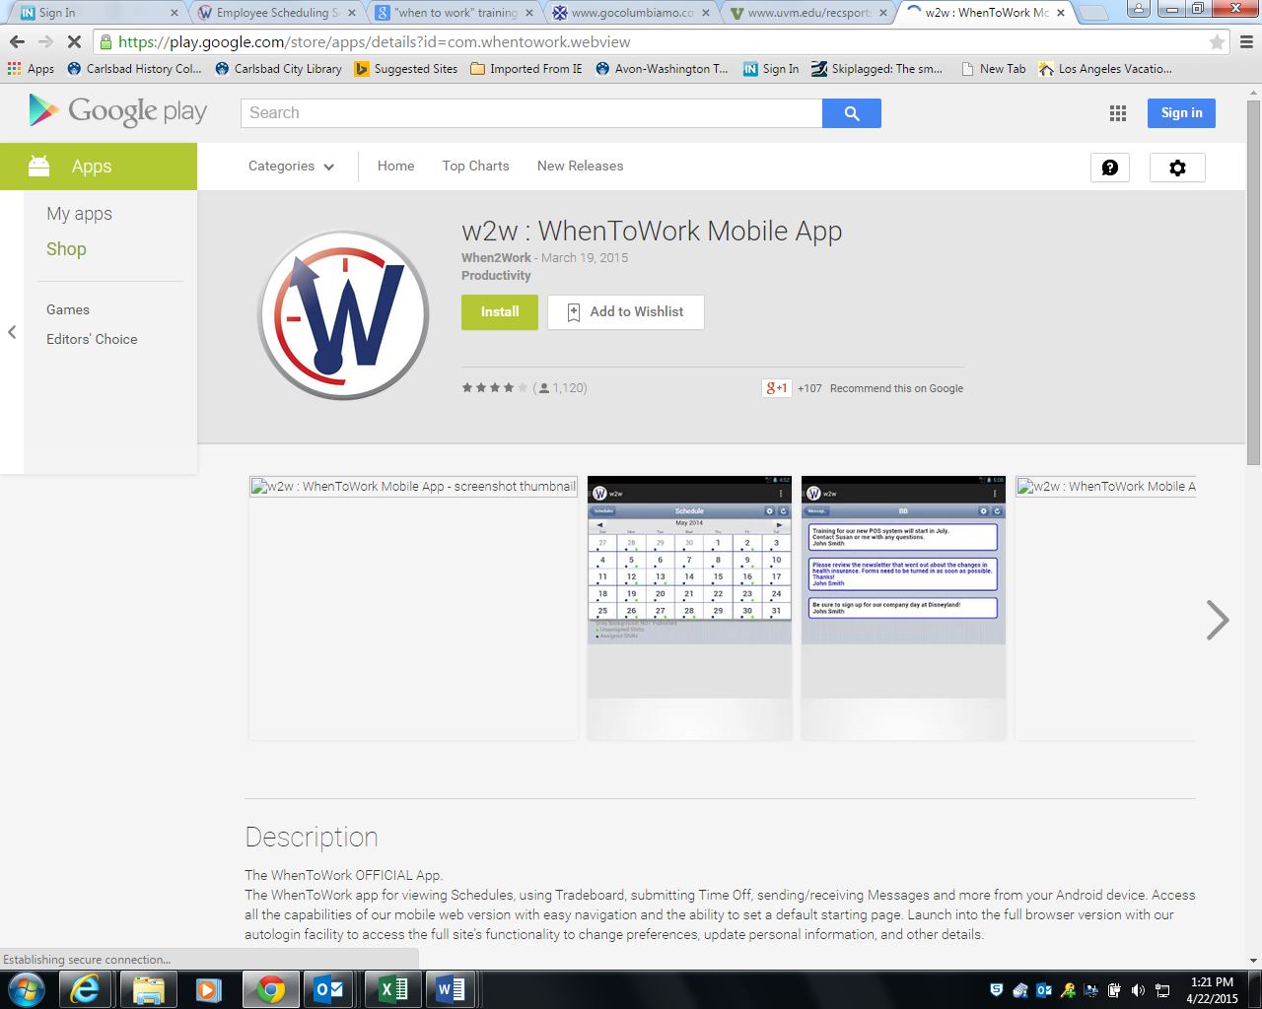

For android devices, go to the play store and install the WhenToWork mobile app:

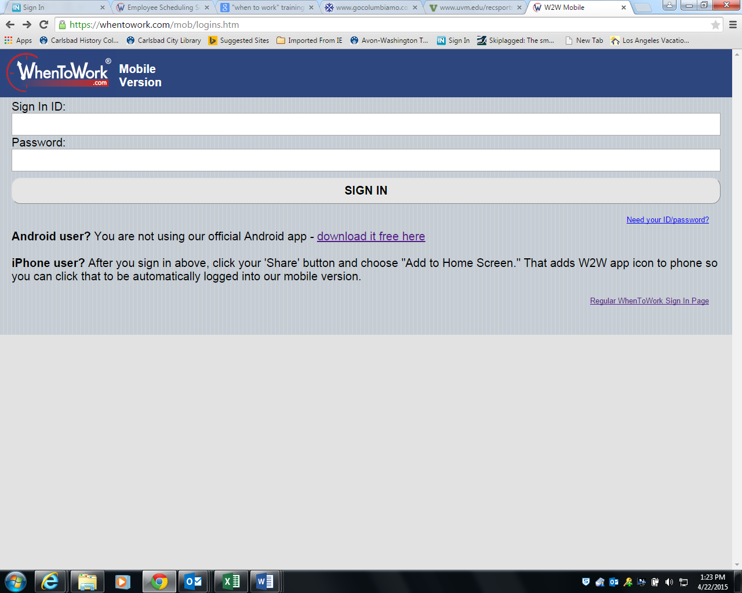

The sign on for the mobile version looks like this:

## Logging into WhenToWork for the First Time

All Scheduling Managers will have an account created by Rec. Admin. An email will be sent to the employee from WhenToWork that will have first-time login credentials. It is recommended that the WhenToWork instructions email not be deleted until after the id/password has been changed.

**Step 1:** Sign in to WhenToWork using the temporary ID and password that was sent to you in the email. Both will start with W2W.

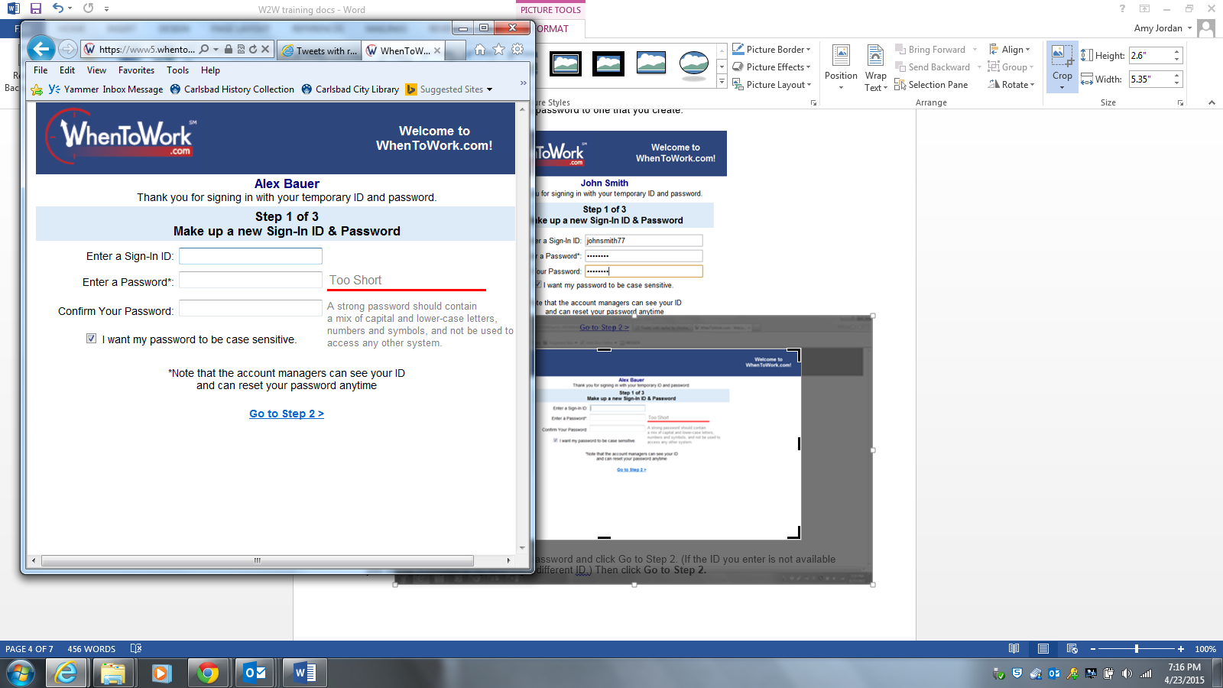

You will be prompted to create a new sign-in ID and password of your choice.

Follow the guidelines for creating a password.

If you do not want the password to be case sensitive, uncheck the box.

*Please note that this password will not be updated when the other scheduled network passwords get changed.*

Click on the *Go to Step 2* link.

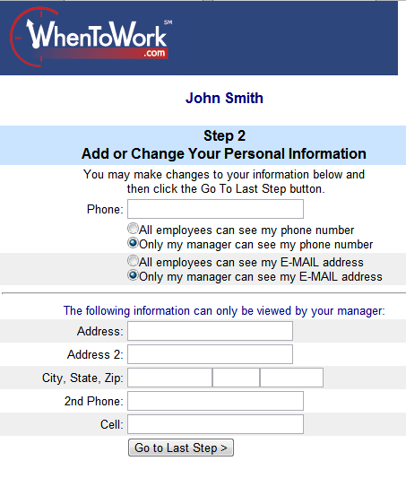

**Step 2:** Enter any information and settings you want added or changed.  After entering or updating, click on the *Go to Last Step* button.

## Personal Home Page

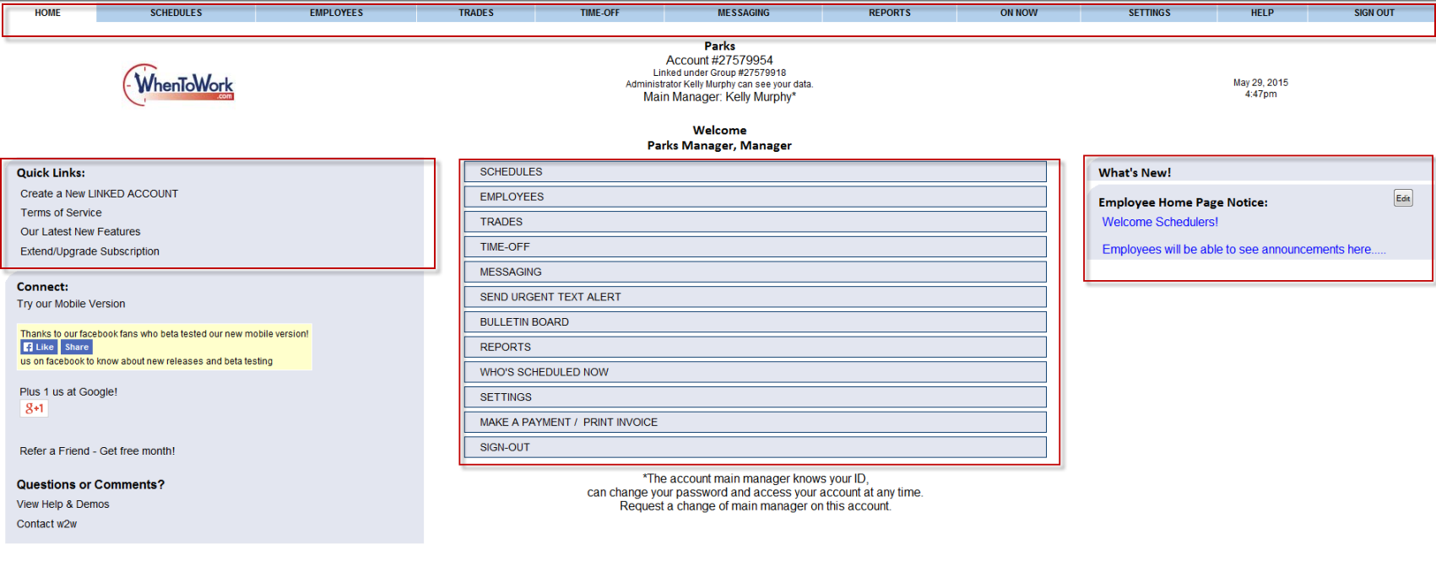After signing in, you will be taken to your personal home page:

Announcements can be posted for employees, you will see it as a **Notice** on the right hand side of your personal home page.

You can use the menu links (at the top of your personal home page) or the menu bars to navigate through the website.

## Getting Help with WhenToWork

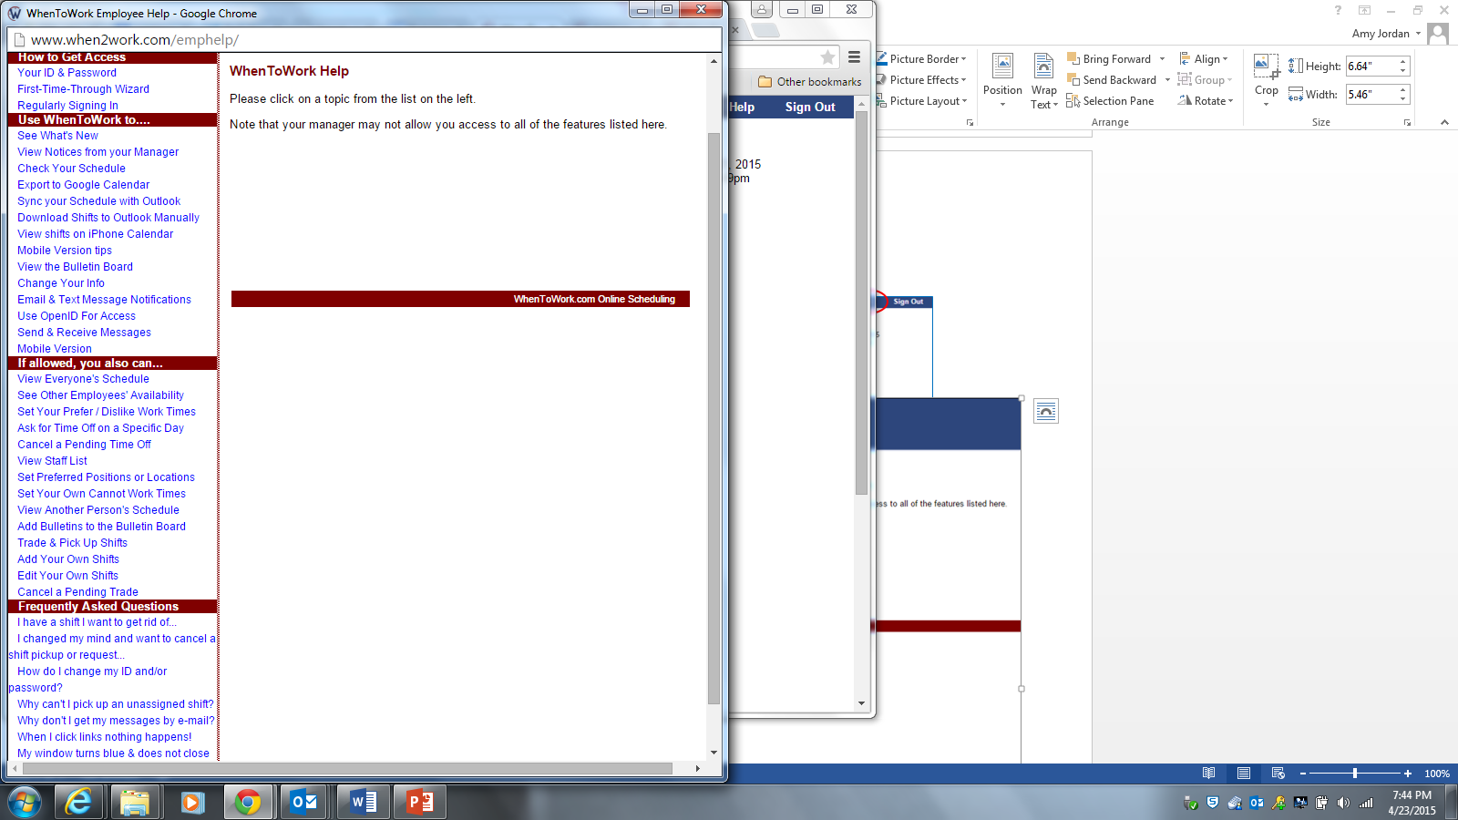Once logged in, help is available on the task bar at the top of the screen:

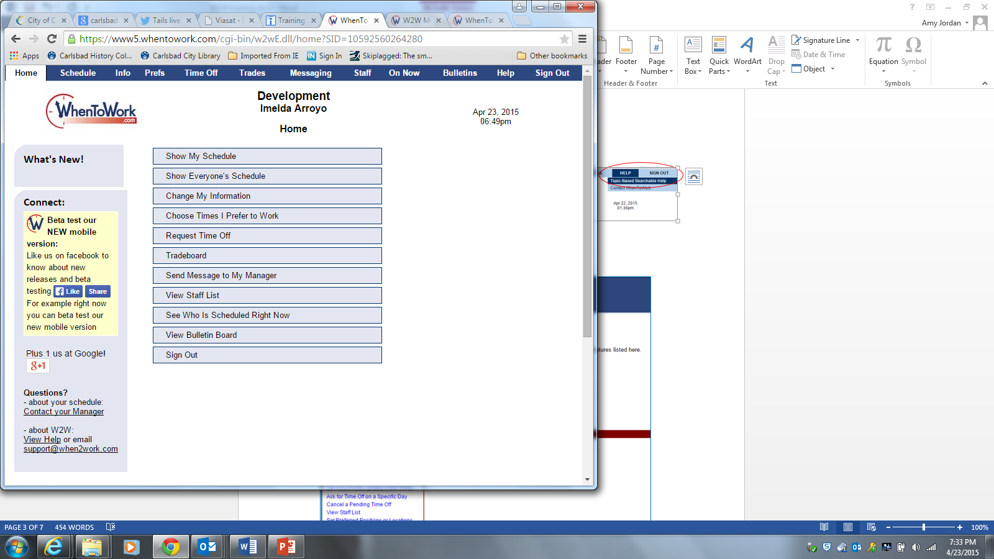

A new window will open.

Click on any link for more information about that topic.

## Forgotten or Invalid Sign-in ID/Password

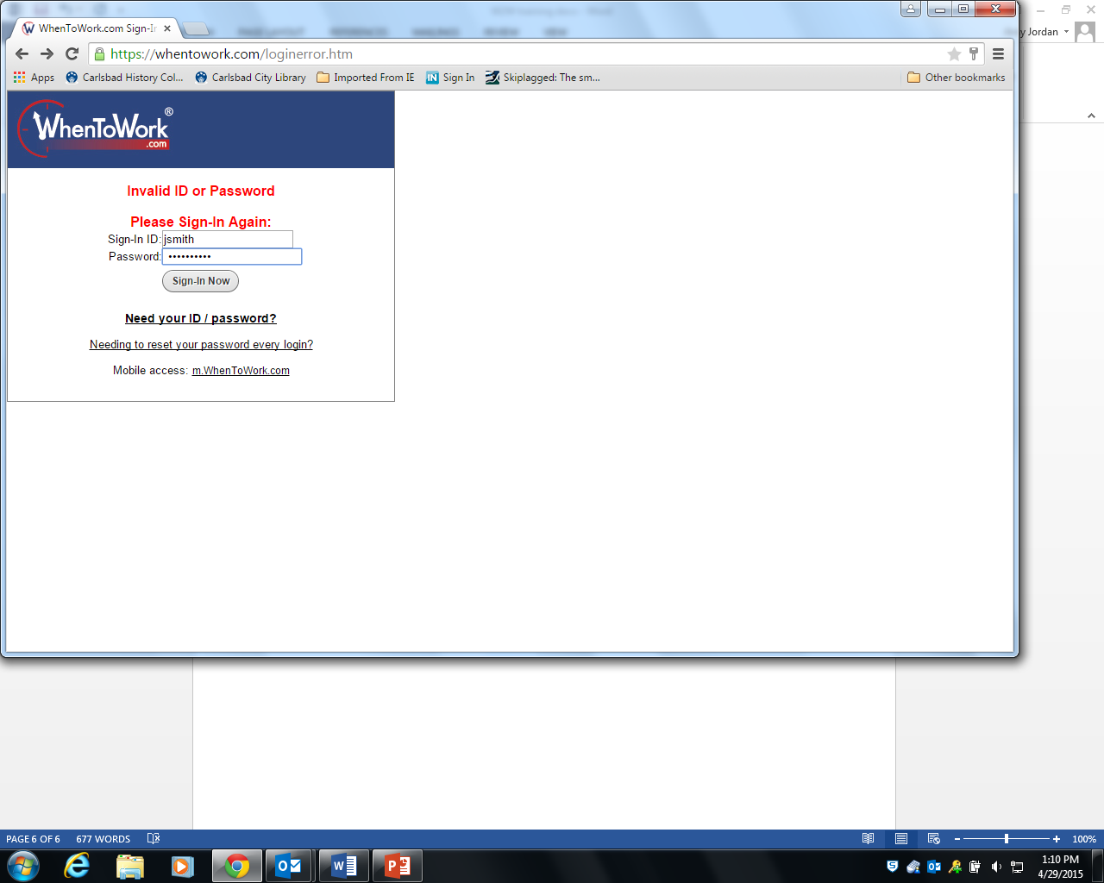If you cannot remember your password, or if you enter an incorrect sign-in or password, an error screen will appear.

Click on the link for *Need your ID/password?*

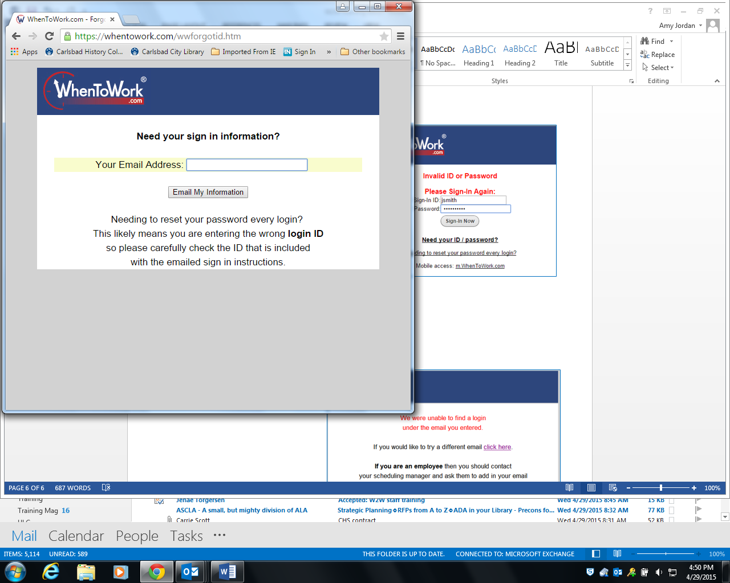

Enter your email address for the account.

Click on *Email My Information*.

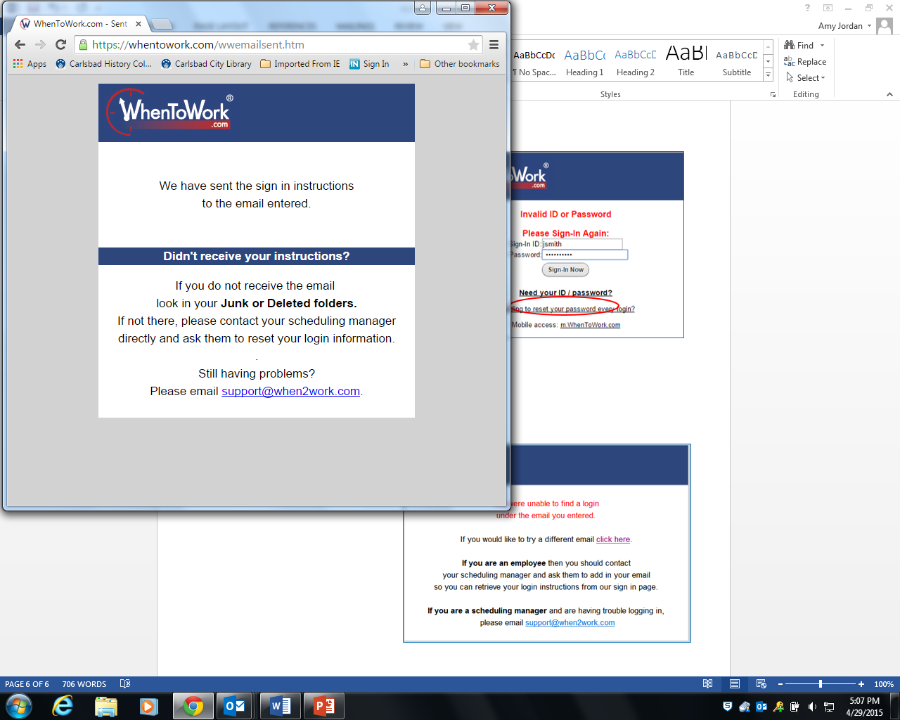If WhenToWork has the address you entered on file, you will receive an email (“*Info You Requested From WhenToWork*”) that contains your sign-in ID and a web link to follow.

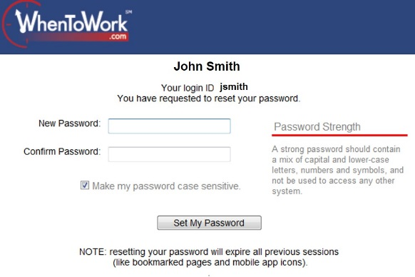

Follow the link from the email so that you can change your password.

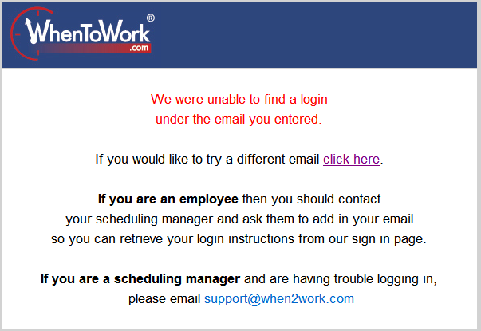

If WhenToWork does **not** have the email address on record, you will get an error message telling you they could not find a record with that email.

You can click on the link to enter a different email address.

If you cannot remember the email you used for the account, or if you need further assistance, **please contact your supervisor**.

WhenToWork Online Scheduling - Before you begin

## 3 Step Overview of Setting up Automatic Scheduling

**STEP 1 - Review your Positions (Jobs) & Employees**

Verify that you have added the Positions (Jobs) that you want to use.

On the Positions Grid you can also check off which Employees can work each position.

You also can add new Employees.

****You can also control what Employees can see and do when they sign in.

**STEP 2 - Your First Schedule**

You are now ready to create your initial schedule. The easiest way to put in your first schedule is to enter the shifts from one of your already prepared schedules.

After entering your first schedule of shifts - your work is done...all that is left to do is Publish if you want at your employees to view it online.

Your future weeks' scheduling can now be automated.

STEP 3 - Future Weeks - Automatic Scheduling

Use Import (**1**.) to bring in the previous week's schedule, (clearing the work assignments) and make any necessary changes to the shifts. Use AutoFill (**2**.) to automatically assign the shifts to the best workers for that particular week. AutoFill will use granted time off and any employee work-time preferences along with each employee's maximum hours/shift per day/week to create the best schedule possible.

Publish (**3**.) the schedule to make it viewable by Employees when they sign into their individual employee account. When you Publish - Employees can also receive their schedules by e-mail.



## Add Your Employees

Add your Employees and be sure each one is set as to which Positions they can work. (You can add other Employee details now or later.) All that is required is a **first name** or initials and the **Positions** they can work. All other information is optional.

### To ADD Employees

From any page: In the top menu click **EMPLOYEES** to go to the List Employee page

Click the **Add New Employee** button to open the Add Employee window



* Type in the Employee's name and check off the Positions they can work (you can also add any other optional information).
* Click **Add this Employee**
* You will see confirmation that the Employee was added and the window will remain up for you to enter another new employee
* Click **Close Window** when you are finished adding employees
* Refresh/Reload the Employee list page to update it with the new employees

## Add your Positions (Jobs)

When you first logged into your account you entered some Positions and Employees. You can always enter more Positions or change your current Positions and set which Employees can work them.

### To Add a New Position

* In the top menu hover over Employees and choose Positions Grid Click the Add / Edit Positions button to open the Add/Edit Positions window
* Type a new Position and click the Add Now button (the new name will appear in list on the right)
* Continue adding positions until you are done
* Close the window and reload/refresh the Positions Grid to update it



Now in the grid set which Employees can work these new Positions:

**EDIT Positions** (Jobs) (to change the way the position label/name displays on all schedules)

**DELETE Positions** (Jobs) if you make a mistake and enter an unnecessary Position you want to completely remove.

## Creating a Schedule

### Enter a Previous Schedule Week - Add Shifts

The easiest way to get your first schedule into our system is to duplicate one of your previously scheduled weeks.

Whether your current schedule is in a spreadsheet on your computer or handwritten on a calendar – you can enter the work assignments into WhenToWork and use that as the basis for future weeks.

Even if your schedule varies from week to week WhenToWork can automate your scheduling and save you hours each week.

Once you have entered your Positions and set which Positions each employee can work you are ready to enter your first weekly schedule which will be the basis for future weeks.

Your first schedule takes the longest to set up - once you have defined your shifts for the first week you can copy it into later weeks and make any necessary changes and then use AutoFill to get the best work assignments for the new week.

Optional: if many of your shifts have the same begin & end times (or unpaid lunch breaks or color etc.) you can Create Categories first so that you can choose them when adding shifts to quickly populate those fields as you add your initial shifts).

### To add your First Shifts use the "By Employee" Schedule View.

(The "By Employee" view is always recommended for creating and editing your schedule)

From any Page:

* Hover over **SCHEDULES** in the top menu and choose **By Employee**
* Click **Week**> to navigate to the week you want to schedule.
* Click the cell that corresponds to the employee and day you want to add a shift (the cursor turns to plus sign) to open the **Quick Shift ADD** window.



1. Add a **Begin** and **End Time** for the shift - Enter the time with the letter a or p after it to indicate AM or PM. (Ex. 815a), or military time (Ex. 2215). You can enter any times you like down to the minute. (The times can later be changed by a manager to reflect actual time worked if you like)
2. **Paid Hours** - (Duration of shift) - if the shift includes unpaid **Lunch period** or break time you can uncheck the **AutoCalc** box and enter the time the employee will be paid for this shift. (Ex. 8am to 5pm with an hour lunch or meal break enter 8 paid hours)
3. In the Quick Shift ADD window **Select a Position** that this shift is for
4. **Check off any other days of the week to add this shift** - to quickly add the same shift for this employee on those days
5. Click **Add Shift** button

Make a mistake? If you need to change any shift you can drag/drop it to another day or employee or **click the shiftto change** the times, position, or employee assigned or to delete it. Or you can use the **Multi-Shift Edit view** to make changes to more than one shift at a time. To copy a shift use Ctrl drag/drop.

**Note**: After adding the shift(s) the window will close and your schedule is immediately updated without the page reloading.

### Optional information that can be entered for any shift

**Optional Text** - can be displayed with the shift on the schedules (Ex. if there are special instructions to the employee, break / lunch times, location notes or meeting times)

**Optional Categories** - If you have shifts with similar begin and end times over multiple Positions, or if you have other reasons to use categories, you can click the Category drop down box and choose Add /Edit Categories to create categories. (Ex. if you have similar night shifts for different positions you can create a NIGHT category and enter and defaults so that when you Add Shifts you can first choose that Category and the fields will be prepopulated (but changeable) for you in the Shift Change window.)

**To add an "Unassigned shift**" - Click the **Add Shifts** button at the top of the schedule (or click on a day in the highlighted unassigned shifts area at the top of the schedule) and leave the worker assigned set to "None - AutoFill."



### Import a Previous Week (or Saved Template)

Once you have entered your first schedule it is easy to create new schedules using the **Import** function. Import any previous week "as is" by choosing a date or Import a saved template by choosing a template name.

When Importing you can check off to unassign all the old work assignments (or do this later with the Clear button) and then **AutoFill** to get the best possible work assignments for the new week. When your schedule is ready you can **publish** and you are done!

Note that by **filtering** your schedule view to a certain position or category before clicking Import you can Import onlythose particular shifts from previous week or template.

### To Create (or add shifts to) a Schedule using Import:

From any weekly Schedule View

* Click **Week>** to navigate to the new week you want to schedule (**1.**)
* (Check that your Category and Position dropdowns are set to show All to import all
* positions and categories in the template or week to import all shifts)
* Click **Import** to open the Import window (**2.**)



* You can Import any other week into the current week (by choosing a date in the **Import a Previous Week** dropdown) or if you have saved Templates you can Import them by choosing the Template name (**3.**)
* Check the box to "Unassign all imported shifts" so that the workers will be cleared when the shifts are brought in (or you can import as assigned and then use the Clear Function later). (**4.**)
* Click **Import Week** button

You also can Import shifts for one day at a time by using the "Import a Day" bottom section in the Import window.

### Make Quick Schedule Changes using the "By Employee" Schedule View

If your schedule changes and you need to add shifts or delete shifts, or if you have changes in work assignments, you can easily make those changes both before or after the schedule has been published. The By Employee view allows you to make changes very quickly without the page reloading between changes and for Internet Explorer users it also allows you to Drag & Drop shifts between days and employees and to Ctrl Drag/Drop to quickly copy shifts.

The By Employee view is the only view that allows you to click a shift and change its position using the Quick Shift EDIT window.

If you change a Published schedule notices can be sent to affected employees if their email has been added and they have chosen that option on their notifications setup page.

To Edit an existing shift using the By Employee view:

On the By Employee view:

* Click on the shift you want to change to open the Quick Shift EDIT window
* Make the changes
* Click the Save Changes button



The Quick Shift EDIT window also has a "Show Available Employees" link at the bottom that opens the **regular Edit Shift** window that is accessed from the other schedule views when you click a shift.

**Editing Multiple Shifts** - if you want to make changes to a number of shifts, you can change the Schedule View dropdown in the upper left of the schedule to Multi-Shift Edit**.** This view allows you sort by any column and then to make multiple changes and then save them all at once.



**Deleting Shifts** - if you need to delete a shift you can click the shift and choose DELETE Shift in the upper left, or to delete a number of shifts, you can change the Schedule View dropdown to Sortable List. This view allows you sort by any column and then to check off the shifts you want to delete and delete them all at once.  
**Adding Shifts** - You can always add more shifts by clicking the Add Shifts button or by clicking the Employee/Date cell on the By Employee Schedule View.  
**Splitting Shifts** - If a shift needs to be split you can click the shift and change the begin or end time and also in the "create copies of this shift field," enter 1 to make a copy of the shift before clicking Save Changes. Then click the new unassigned shift and assign a new employee and change the begin or end time.



### Add Notes to the Weekly Schedule

**\*\*Notes will show up under ALL schedules\*\***

You can create schedule notes associated with any week.

**Add a Note to All Employees** - these are notes that the Managers and Employees see when they view the schedule for that week. Schedule Notes are also sent to employees along with their work times when you Publish the schedule.

Manager Notes- these are notes to yourself and other Managers that the employees do not see. They appear at the bottom of that week's schedule on all views when signed in as a Manager. These private notes do not appear on the printouts.

**To add a note to a weekly schedule:**

From any weekly Schedule Views

* Scroll down to the bottom of the schedule



* Click the "Click here to Add/Edit Notes for this Schedule" link at the Bottom of schedule
* Enter any notes to Employees or Managers
* Click Save

**When Employees sign** in and view the Schedule they can see the Note for that week at the bottom of the schedule.

# Publish Your Schedule

When you Publish a schedule, your Employees will then be able to see that week by signing into their **individual employee accounts**. Employees can also **choose to receive their published schedules via email.**

Employees will see a "**New Schedule**" alert on their employee home page and on the "**By Employee**" schedule vie. Managers will see the icon if they have viewed that schedule week;  if they have been e-mailed their latest schedule for that week, and if they have confirmed receipt of that e-mailed schedule.

Once your schedule is finished and you want to make it visible to your employees when they log in you can click **Publish**. Publishing affects shifts for ALL POSITIONS.

If you would like to Publish more than one week at a time you can navigate to the first week and then click Publish – this will display all future weeks with shifts and you can choose how many weeks to Publish at that time.

**Before publishing you may want to**

* check the **Statistics view** for details and totals on your shifts
* use the **Sortable List view to ANALYZE shifts** to check for any conflicts against the current employee work time preferences and constraints. Conflicts might occur if an Employee has changed their work time preferences since you AutoFilled or created the schedule.

Note: publishing sends notifications to any scheduled Employee if you have **entered their e-mail** and that notification option has been chosen. When the Employee receives the email they can click a link in the e-mail to verify receipt of the schedule. (You can turn off these notifications on your **Settings** page.) You also can **send sign-in instructions** to your employees that includes **their Sign-In ID and password**.

**To Publish:**

From any Unpublished weekly Schedule View:

* Navigate to the week you want to Publish, (or the first week in a series of weeks you want to Publish)
* Click **Publish** to open the Publish Schedule window (which will show you how your SETTINGS option is current notifications on or off)
* To Publish more than one week change the radio button to choose the week you want to schedule through.
* Click the **Publish** button

## Make Schedule Changes (after Publishing)

On a Published schedule you also can make changes to the shifts. **Managers (with permission)** can add, edit, unassign or delete shifts in the same manner as on an Unpublished schedule week (see **Making Schedule Changes**) Normally when you make changes to a published schedule the affected Employees (who have chosen that **notification option**) are automatically sent a notification of the changes with a link to confirm receipt. You can use the "Send Notices" checkbox prevent these notices from being sent out either in the Change Shift window or at the top of the **By Employee, Sortable**

**List** and **Multi-Shift Edit** views).

Note: a log of all changes to a shift in the last 30 days can be viewed by clicking the "Shift History" link after clicking a shift.

**By Employee View** - Changes can quickly be made on the "By Employee" schedule view by using the **Drag & Drop** and Quick Shift EDIT/ADD functions. You can use the checkbox at the top of that view to turn on/off notifications when changes are made.

 **To**

**To prevent notices from going out when you make changes to a single shift:**

On any Published weekly Schedule View:

* Click on the shift to open the Shift Change window
* Uncheck the box next to "Send Notices To Affected Employees"
* Make the changes to the shift
* Click **Save Changes**

**OR to change a number of shifts at one time and not send out notifications:**

**On any Published Schedule View**

* In the Schedule View dropdown choose Multi-Shift Edit (you can click a day tab to see one day or the WEEK to view shifts for the whole week)
* Make the changes to shifts (the rows changed will appear green)
* Uncheck the "Send Notices To Affected Employees" box
* Click **Save Changes**



# Create a WEEKLY Schedule Template

## How to create a WEEKLY Schedule "Template"

You can Import any previous week "as is" by choosing that date in the Import window but if you want to create and name certain weekly schedule "templates" (Ex. if you want to create a holiday schedule and save/name it as a template for later importing) you can do so at any time. You can save any schedule that you have on the screen or you can navigate to an empty week (future or past) and create a schedule and save as template.

When you are finished creating the template click Save Template and name it. If you used an empty week to create the template be sure to use the Clear/Delete function to "Erase the Entire Schedule" - removing the shifts from that week and setting that week back to empty after saving as a template.

Note that when saving or importing templates you can first filter your view to only include a specific position, category or group so that the template will only include those shifts. Ex: I can filter my schedule to only include shifts for one position and then "Save as Template" to create a template that includes only those shifts for that position.

From any weekly Schedule View

* Either use a week you currently have on screen OR Navigate to an empty week (past or future) by clicking the "Week of..." row to temporarily create your shifts in that week
* Click Add Shifts (or Import) to create your shifts
* Make any changes or Clear/Delete work assignments
* Click Save Template to open the Save Schedule window
* Type a name for this template and click Save WEEK
* When the warning asks if are you sure you want to save click OK

# Import Shifts into a Week or Day

* WhenToWork.com Online Scheduling
* Full or partial schedules can be imported into a Week or Day.
* You can import a complete schedule or only certain positions or categories
* You can import and remove any existing shifts in that day/week, or import and keep the existing shifts
* You can import any other week or day's shifts by choosing that week from the list
* You can also import previously Saved and Named Weekly or Daily Templates

## To Import All Shifts

From any weekly Unpublished Schedule View

* Click **Import** to open the Import window. To Import a Week use the top section - for a Day use
* the bottom section
* Choose the "Template" or "By Date" week/day you want to import
* Set whether you want to "Unassign all imported shifts" (most users will choose this to clear work assignments so that they can use AutoFill to automatically assign the shifts later based on the new week's availability).
* Optional - If you want all the imported shifts to have a certain Shift Text (for instance to specify an event or location) type the optional text
* Click Import Day or Import Week



**Import is only available on weekly UnPublished Schedules**

# Change a Saved Template (Edit a Template)

WhenToWork.com Online Scheduling

Once you have saved a template you can open it, make changes and resave it by going to an empty schedule week, importing the template, making changes to it and resaving it with the same name.

## To make changes to or edit a Template:

From any weekly Schedule View:

* **Navigate to any empty UnPublished week** (one that has no shifts in it) past or future
* Click **Import** to open the Import Shifts window



* In the Import a Template dropdown **choose the template** you want to change
* Click the **Import WEEK** button (or Import DAY if you are changing a day template) (Your Schedule will now display the shifts in your Template)
* Make the changes to your shifts - when all changes are made click Save Template to open the
* Save as Template window



* Choose the template name from the dropdown (ex. Inventory Week)
* Click **Save WEEK** (or Save DAY if changing a day template)
* Be sure to use **Clear/Delete** to change the previously empty week back to being empty

Your template is then changed and will show the changes the next time you Import it

## Delete a Schedule Template

When you save a schedule template it is available under "Import a Template" in the Import Window. If you want to delete a saved Template from that list you can do so.

From any weekly Schedule View

* Click **Import** or **Save Template** to open the Import Shifts window **(1.)**



**C**lick **Delete a Week Template** or **Delete Day Template** link to open the Delete Saved Template

window **(2.)**

* Choose the template you want to delete **(3.)**
* Click **Delete (4.)**

Deleting saved templates does not affect any created schedules or the ability to import regular weekly schedules by the date.

# Change Layout - Font size, Name Order, Sorting, etc.

Most Schedule views have a Change Layout link in the upper left. Depending on the view, you can change various layout options for that display page and printout. Some of the options include or omit information, change font sizes, change the way employee names appear (first, last), set operating hours to show etc. Be sure to explore all of the Layout options using the Change Layout links. The selected layout settings will remain active for you in the future for each view until you change them again.



The Calendar Monthly view "Change Layout" link also allows you to change the beginning display day

for that view



# Overview of the 12 Schedule Views

## Standard Schedule Views

* **Calendar Daily** - planner layout with workers listed for each hour
* **Calendar Weekly** - one of our most popular, weekly view in calendar format with many change layout options, can group shifts by position or category
* **Calendar Monthly** - similar to monthly calendar, can group shifts by position or category
* **By Position** - Daily and Weekly Tabs – Lists shifts by Position. Shows total shifts and hours for each Position
* **Graphical** - Daily and Weekly Tabs – Shows shifts in a graphical format similar to a spreadsheet. Layout can be changed to only Show certain time period - show by Employee or Position.
* **Category Chart** - most useful if you use Categories, providing a compressed chart for time periods between 1 week and a month
* **In-Out Time Chart** - similar to Category Chart but shows the time first shift starts and time last shift ends for the day, this view is useful if you schedule employees to more than one shift per day

## Special Schedule Views

* **By Employee** - Default "working" weekly view. Lists employees down the left. Shows their schedule for the week and if the week is published shows icons for each employee if they have viewed, received and confirmed receipt of the schedule Allows dragging and dropping shifts and quick editing (the Quick Shift Edit window also allows you to change the shift's Position). You can also Ctrl Drag/Drop to quickly make copies of shifts.
* **Availability** - Daily - Graphically displays all employees - the shifts they are working overlaid on their work time preferences and shows time off and the counts for coverage and availability. Layout can be changed to only show a certain time period - specific time periods can be saved for quick viewing later.
* **Sortable List** - Daily and Weekly Tabs - List of Shifts can be sorted by any column. Also allows for deleting and unassigning multiple shifts. Can be filtered to show only Unassigned Shifts, Auto-Filled Shifts or Preplaced Shifts. Also used to Analyze Shifts to check for any conflicts.
* **Multi-Shift Edit** - Daily and Weekly Tabs - (List of Shifts can be sorted by any column). Allows editing of multiple shifts at one time. Can be filtered to show only Unassigned Shifts, Auto-Filled Shifts or Preplaced Shifts
* **Statistics** - shows at a glance statistics about the weekly schedules. On published weeks this view shows whether or not employees have viewed or confirmed receipt of that schedule.

Any Schedule View can be filtered to only show certain Positions, Position Groups, Categories etc.

# To MOVE a shift to another day/employee

## On the By Employee schedule view

* Click and hold down the left mouse button on a shift and drag it to another day and/or employee
* Move mouse to the background of an employee row & day, then "drop" the shift by releasing the mouse (note dropping a shift on top of another shift will mean you want to SWAP the shifts instead of just move the shift).
* The schedule will immediately be changed.
* Note you can also drop the shift directly onto the employee's name on the left to have the shift assigned to that employee on the same day.
* If the employee is not set to work that position or is unavailable, you will see an alert and the change will not be made. If adding the shift puts the employee over their maximum hours per week, the shift will be changed but you will see an alert.
* You can click the UNDO Drag/Drop to change the shifts back (UNDO can be used any number of times to undo back the last change you have just made on that week)



## To COPY a shift to another day/employee

On the **By Employee schedule** view

* Hold down the Ctrl key and click and hold down the left mouse button on a shift and drag it to another day and/or employee and drop it over the cell background On the By Employee schedule view

***Note that Ctrl dragging shifts to copy them cannot be undone with the UNDO button, but you can click the shift and then the Delete link to remove the shift.***

## To SWAP two shifts

* Click and hold down the mouse on first shift and move it on top of second shift.
* Release the mouse to drop the shift on top of other shift
* You will see a warning that asks if you want to swap the shifts - click OK
* If the other employee is not set to work that position or is unavailable at that time you will see an alert and the change will not be made. If adding the shift puts the other employee over their maximum hours per week the shift will be changed but you will see an alert.

